Product Haul UI Flow

1. **Start Point: Schedule Product Haul from a blend**

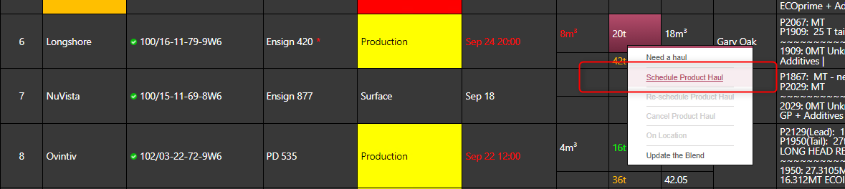

The blend in eService can be flagged as “Blend Test” which is bought to the interface.

* 1. **Not “Blend Test”**

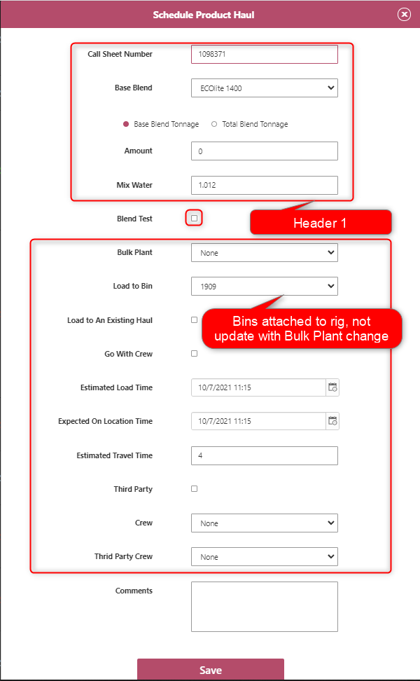

* + 1. **Not Existing Haul**

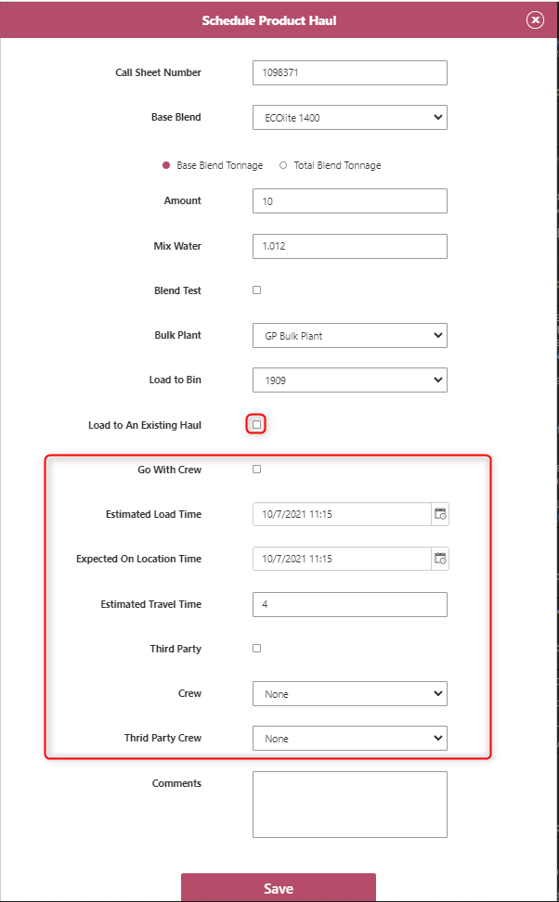

* + - 1. **Not Go with Crew**

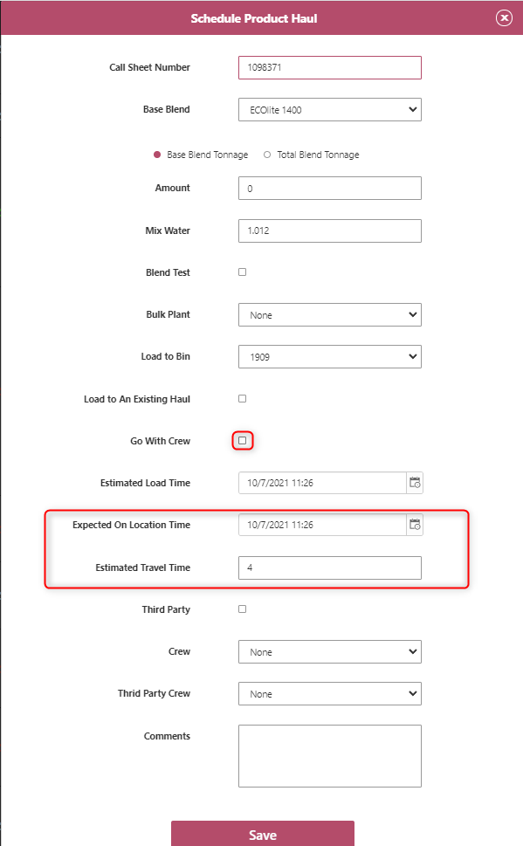

* + - * 1. **Not Use Third Party Crew**

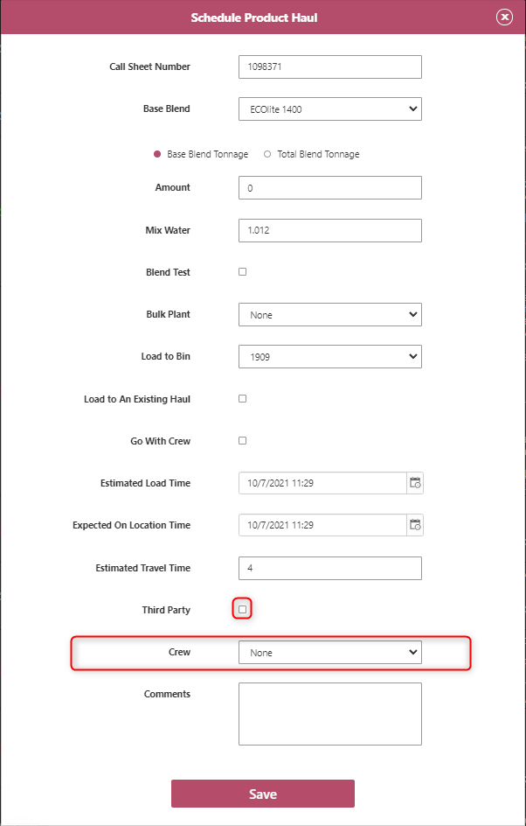

* + - * 1. **Use Third Party Crew**

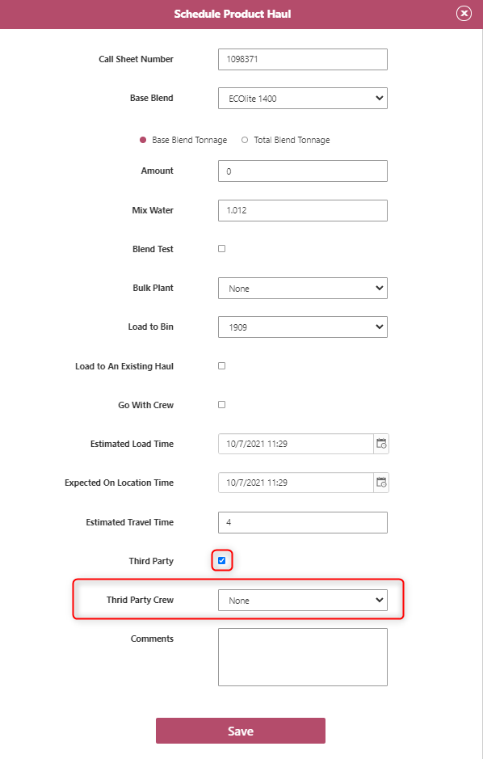

* + - * 1. **Go With Crew**

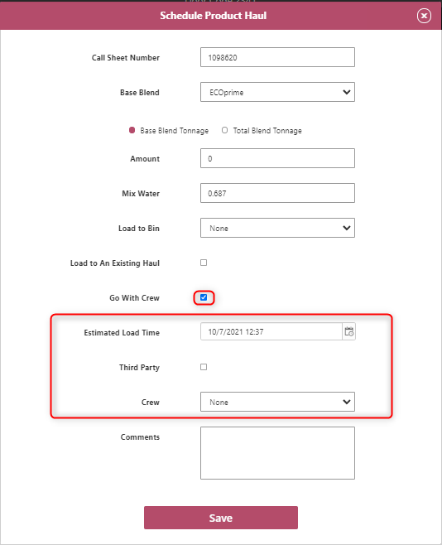

* + - * 1. **Go with Crew using Third Party**

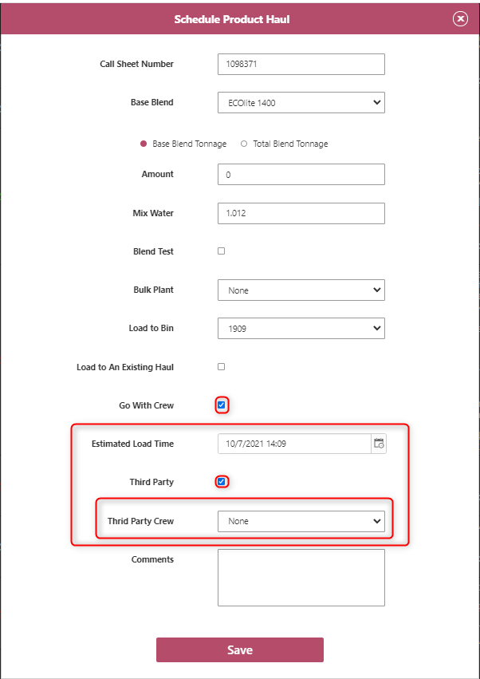

**1.1.2 Use Existing Haul**

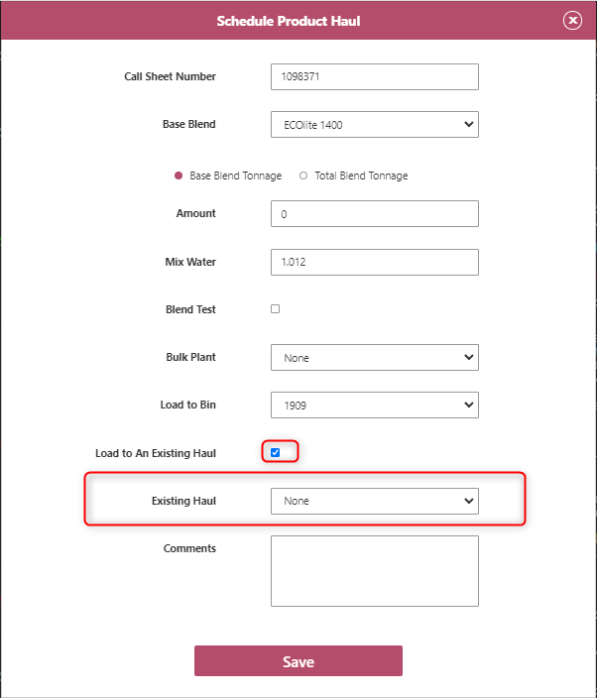

* 1. **Blend Test**

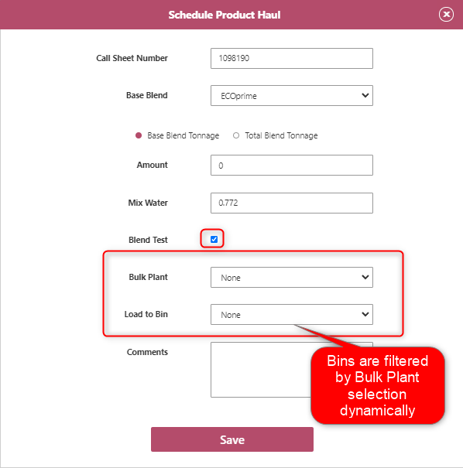

1. **Start Point: Schedule Product Haul from Bulk Plant**

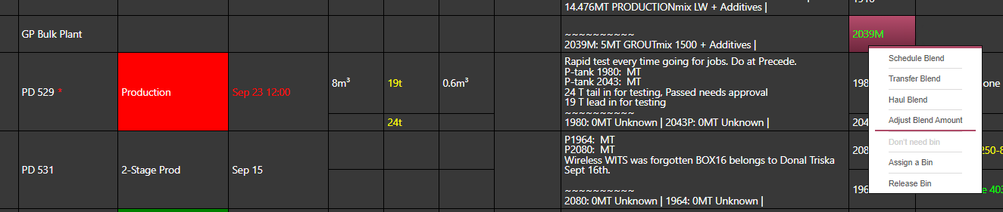

**2.1 Schedule Blend**

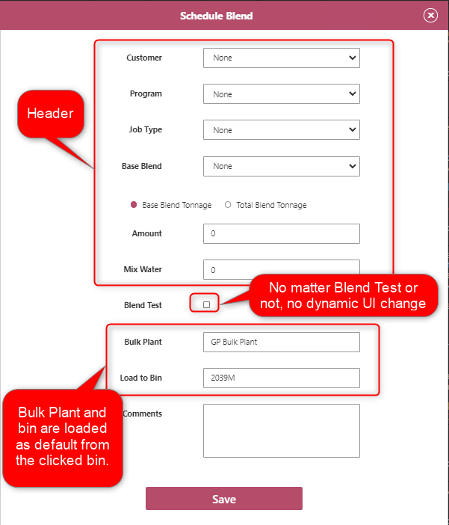

**2.2 Haul Blend**

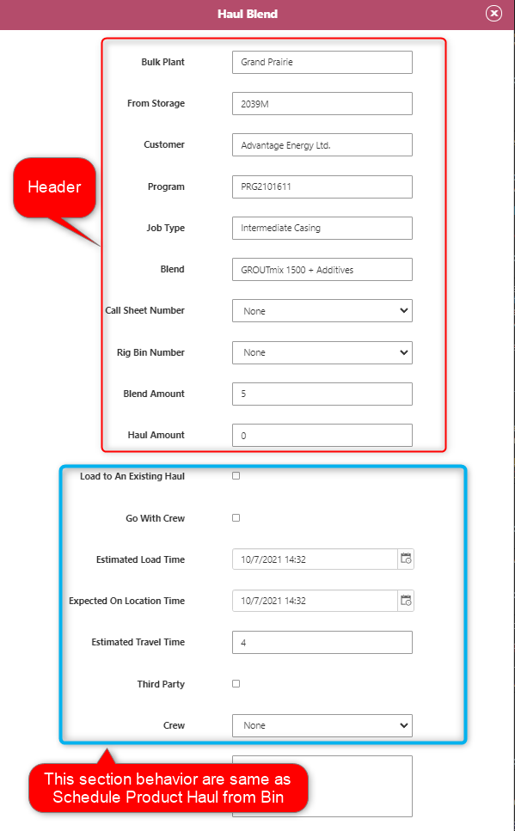

**2.3 Transfer Blend**

1. **Start Point: Schedule Blend from Rig Bin**

